**Supplementary material**

**Table S1**

An overview of the associations between the variables of interest.

|  |  |  |  |  |  |  |  |  |  |  |  |  |
| --- | --- | --- | --- | --- | --- | --- | --- | --- | --- | --- | --- | --- |
|  | 1 | 2 | 3 | 4 | 5 | 6 | 7 | 8 | 9 | 10 | 11 | 12 |
| 1. STLS-45 | — |  |  |  |  |  |  |  |  |  |  |  |
| 2. Intimacy | 0.892*** | — |  |  |  |  |  |  |  |  |  |  |
| 3. Passion | 0.907*** | 0.699*** | — |  |  |  |  |  |  |  |  |  |
| 4. Commitment | 0.923*** | 0.764*** | 0.752*** | — |  |  |  |  |  |  |  |  |
| 5. Passionate Love a | 0.363*** | -0.028** | 0.673*** | 0.292*** | — |  |  |  |  |  |  |  |
| 6. Modernization b | 0.119*** | 0.190*** | 0.040*** | 0.115*** | -0.134*** | — |  |  |  |  |  |  |
| 7. HDI c | 0.163*** | 0.235*** | 0.075*** | 0.157*** | -0.133*** | 0.925*** | — |  |  |  |  |  |
| 8. Gender inequality | -0.122*** | -0.186*** | -0.038*** | -0.119*** | 0.129*** | -0.860*** | -0.892*** | — |  |  |  |  |
| 9. Collectivism d | 0.003 | -0.018 | 0.025* | 0.0000 | 0.046*** | -0.612*** | -0.410*** | 0.404*** | — |  |  |  |
| 10. Temperature e | -0.052*** | -0.110*** | 0.014 | -0.055*** | 0.125*** | -0.566*** | -0.626*** | 0.625*** | 0.196*** | — |  |  |
| 11. Relationship length f | 0.002 | -0.010 | -0.070*** | 0.094*** | -0.091*** | 0.079*** | 0.100*** | -0.087*** | -0.012 | -0.023* | — |  |
| 12. Sex g | -0.003 | 0.047*** | -0.045*** | -0.006 | -0.102*** | 0.011 | 0.009 | -0.008 | -0.001 | 0.010 | 0.028* | — |
| 13. Age | -0.026* | -0.044*** | -0.087*** | 0.069*** | -0.082*** | 0.053*** | 0.063*** | -0.058*** | -0.021* | 0.032** | 0.829*** | -0.061*** |

*Note.* a Passionate Love–Passion to Intimacy ratio, b Modernization–World Modernization Index (WMI) per country, c HDI–Human Development Index, d Collectivism-in-group favoritism, e Temperature–Average annual temperatures, f Relationship length in months, g Sex–Men coded as a reference group. * p < 0.05, ** p < 0.01, *** p < 0.001.

**Table S2**

Pseudo *r2* across the multilevel models with love and love subscales as outcome variables and country-level collectivism, average annual temperature, Participants’ sex and relationship length, and either Modernization Index, Gender Inequality Index, or Human Development Index as predictor variables.

|  |  |  |  |  |  |  |
| --- | --- | --- | --- | --- | --- | --- |
|  | STLS-45 | | Intimacy | Passion | Commitment | Passionate Love |
| Modernization | 0.018 |  | 0.046 | 0.016 | 0.022 | **0.046** |
| Gender inequality | 0.011 |  | 0.024 | 0.015 | 0.019 | 0.033 |
| HDI | **0.032** |  | **0.065** | **0.021** | **0.035** | 0.041 |

*Note.* Bolded are models with the most explained variance.

**Table S3**

Results of the multilevel linear models regressing love components (i.e., STLS-45, Intimacy, Passion, and Commitment) on countries’ levels of Modernization Index, Collectivism level, annual average temperature, and participants’ sex and length of relationship (in months), with participants nested within countries.

|  |  |  |  |  |  |  |
| --- | --- | --- | --- | --- | --- | --- |
|  | **Fixed effects** | | | | |  |
|  | **Modernization** a | **Collectivism** b | **Temperature** c | **Sex** d | **Relationship length** e | |
| **STLS-45** |  |  |  |  |  | |
| ***β*** | 0.181 | 0.08 | 0.056 | -0.019 | -0.015 | |
| SE | 0.053 | 0.043 | 0.039 | 0.011 | 0.011 | |
| 95% CI | [0.053,0.076] | [0.043,-0.004] | [0.039,-0.02] | [0.011,-0.041] | [0.011,-0.037] | |
| *p* | 0.001*** | 0.063 | 0.149 | 0.097 | 0.192 | |
| **Intimacy** |  |  |  |  |  | |
| ***β*** | 0.264 | 0.11 | 0.031 | 0.021 | -0.027 | |
| SE | 0.055 | 0.045 | 0.041 | 0.011 | 0.011 | |
| 95% CI | [0.055,0.156] | [0.045,0.022] | [0.041,-0.049] | [0.011,-0.001] | [0.011,-0.049] | |
| *p* | < 0.001*** | 0.014* | 0.448 | 0.057 | 0.015* | |
| **Passion** |  |  |  |  |  | |
| ***β*** | 0.099 | 0.051 | 0.092 | -0.045 | -0.082 | |
| SE | 0.056 | 0.046 | 0.041 | 0.012 | 0.011 | |
| 95% CI | [0.056,-0.012] | [0.046,-0.039] | [0.041,0.011] | [0.012,-0.068] | [0.011,-0.104] | |
| *p* | 0.080 | 0.265 | 0.026* | < 0.001*** | < 0.001*** | |
| **Commitment** |  |  |  |  |  | |
| ***β*** | 0.169 | 0.069 | 0.038 | -0.022 | 0.076 | |
| SE | 0.048 | 0.039 | 0.035 | 0.012 | 0.011 | |
| 95% CI | [0.048,0.075] | [0.039,-0.007] | [0.035,-0.032] | [0.012,-0.045] | [0.011,0.054] | |
| *p* | < 0.001*** | 0.076 | 0.289 | 0.052 | < 0.001*** | |
| **Passionate love** |  |  |  |  |  | |
| ***β*** | -0.131 | -0.045 | 0.088 | -0.073 | -0.089 | |
| SE | 0.054 | 0.044 | 0.04 | 0.011 | 0.011 | |
| 95% CI | [0.054,-0.238] | [0.044,-0.132] | [0.04,0.01] | [0.011,-0.095] | [0.011,-0.111] | |
| *p* | 0.016* | 0.303 | 0.028* | < 0.001*** | < 0.001*** | |

*Note.* \**p* < 0.05, \*\**p* < 0.01, \*\*\**p* < 0.001. a Human Development Index, b Collectivism-in-group favoritism, c Average annual temperatures, d Participants’ sex with men as a reference group, e Participants’ relationship length in months. Random effect: STLS-45 variance = 0.043, SD = 0.207, Intimacy variance = 0.047, SD = 0.216, Passion variance = 0.049, SD = 0.221, Commitment variance = 0.033, SD = 0.182, Passionate love variance = 0.047, SD = 0.217, ICC for STLS-45 = 0.048, ICC for Intimacy = 0.055, ICC for Passion = 0.052, ICC for Commitment = 0.037, ICC for Passionate love = 0.050, Pseudo *r2* for STLS-45 = 0.018, Pseudo *r2* for Intimacy = 0.024, Pseudo *r2* for Passion = 0.016, Pseudo *r2* for Commitment = 0.022, Pseudo *r2* for Passionate love = 0.046, dfresiduals for STLS-45 = 7106, dfresiduals for Intimacy = 7106, dfresiduals for Passion = 7099, dfresiduals for Commitment = 7035, dfresiduals for Passionate love = 7099, deviance for STLS-45 = 19072.6, deviance for Intimacy = 18700.7, deviance for Passion = 19412.2, deviance for Commitment = 18931.8, deviance for Passionate love = 19428.9.

**Table S4**

Results of the multilevel linear models regressing love components (i.e., STLS-45, Intimacy, Passion, and Commitment) on countries’ levels of Gender Inequality Index, Collectivism level, annual average temperature, and participants’ sex and length of relationship (in months), with participants nested within countries.

|  |  |  |  |  |  |  |
| --- | --- | --- | --- | --- | --- | --- |
|  | **Fixed effects** | | | | |  |
|  | **Gender Inequality** a | **Collectivism** b | **Temperature** c | **Sex** d | **Relationship length** e | |
| **STLS-45** |  |  |  |  |  | |
| ***β*** | -0.138 | 0.036 | 0.075 | -0.011 | -0.016 | |
| SE | 0.051 | 0.038 | 0.041 | 0.011 | 0.011 | |
| 95% CI | [0.051,-0.237] | [0.038,-0.038] | [0.041,-0.006] | [0.011,-0.033] | [0.011,-0.039] | |
| *p* | 0.007** | 0.338 | 0.069 | 0.344 | 0.143 | |
| **Intimacy** |  |  |  |  |  | |
| ***β*** | -0.178 | 0.041 | 0.056 | 0.033 | -0.033 | |
| SE | 0.058 | 0.043 | 0.046 | 0.011 | 0.011 | |
| 95% CI | [0.058,-0.291] | [0.043,-0.043] | [0.046,-0.035] | [0.011,0.011] | [0.011,-0.054] | |
| *p* | 0.002** | 0.340 | 0.226 | 0.003** | 0.003** | |
| **Passion** |  |  |  |  |  | |
| ***β*** | -0.069 | 0.027 | 0.097 | -0.038 | -0.084 | |
| SE | 0.052 | 0.039 | 0.042 | 0.011 | 0.011 | |
| 95% CI | [0.052,-0.172] | [0.039,-0.05] | [0.042,0.014] | [0.011,-0.06] | [0.011,-0.106] | |
| *p* | 0.189 | 0.491 | 0.022* | < 0.001*** | < 0.001*** | |
| **Commitment** |  |  |  |  |  | |
| ***β*** | -0.142 | 0.027 | 0.054 | -0.017 | 0.079 | |
| SE | 0.046 | 0.034 | 0.037 | 0.011 | 0.011 | |
| 95% CI | [0.046,-0.232] | [0.034,-0.04] | [0.037,-0.019] | [0.011,-0.039] | [0.011,0.057] | |
| *p* | 0.002** | 0.423 | 0.147 | 0.139 | < 0.001*** | |
| **Passionate love** |  |  |  |  |  | |
| ***β*** | 0.084 | -0.008 | 0.073 | -0.071 | -0.086 | |
| SE | 0.055 | 0.041 | 0.044 | 0.011 | 0.011 | |
| 95% CI | [0.055,-0.024] | [0.041,-0.088] | [0.044,-0.013] | [0.011,-0.094] | [0.011,-0.108] | |
| *p* | 0.126 | 0.847 | 0.098 | < 0.001*** | < 0.001*** | |

*Note.* \**p* < 0.05, \*\**p* < 0.01, \*\*\**p* < 0.001. a Human Development Index, b Collectivism-in-group favoritism, c Average annual temperatures, d Participants’ sex with men as a reference group, e Participants’ relationship length in months. Random effect: STLS-45 variance = 0.044, SD = 0.209, Intimacy variance = 0.056, SD = 0.237, Passion variance = 0.049, SD = 0.221, Commitment variance = 0.034, SD = 0.185, Passionate love variance = 0.055, SD = 0.235, ICC for STLS-45 = 0.050, ICC for Intimacy = 0.068, ICC for Passion = 0.052, ICC for Commitment = 0.039, ICC for Passionate love = 0.050, Pseudo *r2* for STLS-45 = 0.011, Pseudo *r2* for Intimacy = 0.024, Pseudo *r2* for Passion = 0.015, Pseudo *r2* for Commitment = 0.019, Pseudo *r2* for Passionate love = 0.046, dfresiduals for STLS-45 = 7187, dfresiduals for Intimacy = 7187, dfresiduals for Passion = 7179, dfresiduals for Commitment = 7114, dfresiduals for Passionate love = 7149, deviance for STLS-45 = 19119.2, deviance for Intimacy = 18595.9, deviance for Passion = 19604.4, deviance for Commitment = 19050.5, deviance for Passionate Love = 19733.7.

**Table S5**

Results of the multilevel linear models regressing love components (i.e., STLS-45, Intimacy, Passion, and Commitment) on countries’ levels of Human Development Index (HDI), Collectivism level, annual average temperature, and participants’ sex and age (in years), with participants nested within countries.

|  |  |  |  |  |  |  |
| --- | --- | --- | --- | --- | --- | --- |
|  | **Fixed effects** | | | | |  |
|  | **HDI** a | **Collectivism** b | **Temperature** c | **Sex** d | **Age** e | |
| **STLS-45** |  |  |  |  |  | |
| *β* | 0.194 | 0.054 | 0.090 | -0.004 | -0.034 | |
| SE | 0.046 | 0.035 | 0.038 | 0.010 | 0.010 | |
| 95% CI | [0.103,0.285] | [-0.014,0.121] | [0.015,0.165] | [-0.023,0.016] | [-0.053,-0.014] | |
| *p* | < 0.001*** | 0.121 | 0.019* | 0.718 | 0.001*** | |
| **Intimacy** |  |  |  |  |  | |
| *β* | 0.258 | 0.061 | 0.07 | 0.043 | -0.051 | |
| SE | 0.050 | 0.038 | 0.042 | 0.010 | 0.010 | |
| 95% CI | [0.159,0.357] | [-0.013,0.135] | [-0.011,0.152] | [0.024,0.062] | [-0.07,-0.032] | |
| *p* | < 0.001*** | 0.104 | 0.091 | < 0.001*** | < 0.001*** | |
| **Passion** |  |  |  |  |  | |
| *β* | 0.122 | 0.042 | 0.116 | -0.047 | -0.093 | |
| SE | 0.047 | 0.035 | 0.038 | 0.010 | 0.010 | |
| 95% CI | [0.031,0.213] | [-0.026,0.11] | [0.04,0.191] | [-0.067,-0.027] | [-0.113,-0.074] | |
| *p* | 0.009** | 0.228 | 0.003** | < 0.001*** | < 0.001*** | |
| **Commitment** |  |  |  |  |  | |
| *β* | 0.173 | 0.055 | 0.069 | 0.000 | 0.059 | |
| SE | 0.042 | 0.031 | 0.034 | 0.010 | 0.010 | |
| 95% CI | [0.091,0.255] | [-0.007,0.117] | [0.002,0.136] | [-0.02,0.02] | [0.039,0.079] | |
| *p* | < 0.001*** | 0.080 | 0.043* | 0.975 | < 0.001*** | |
| **Passionate** **Love** |  |  |  |  |  | |
| *β* | -0.099 | -0.012 | 0.079 | -0.101 | -0.083 | |
| SE | 0.045 | 0.033 | 0.037 | 0.010 | 0.010 | |
| 95% CI | [-0.187,-0.012] | [-0.077,0.054] | [0.007,0.152] | [-0.121,-0.082] | [-0.103,-0.064] | |
| *p* | 0.026* | 0.728 | 0.031* | < 0.001*** | < 0.001*** | |

*Note. *p < 0.05, **p < 0.01, ***p < 0.001. a Human Development Index, b Collectivism-in-group favoritism, c Average annual temperatures, d Participants’ sex with men as a reference group, e Participants’ age in years. Random effect: STLS-45 variance = 0.041, SD = 0.202, Intimacy variance = 0.049, SD = 0.222, Passion variance = 0.041, SD = 0.203, Commitment variance = 0.032, SD = 0.178, Passionate Love variance = 0.037, SD = 0.193, ICC for STLS-45 = 0.042, ICC for Intimacy = 0.053, ICC for Passion = 0.042, ICC for Commitment = 0.033, ICC for Passionate Love = 0.039, Pseudo r2 for STLS-45 = 0.022, Pseudo r2 for Intimacy =0.047, Pseudo r2 for Passion = 0.020, Pseudo r2 for Commitment = 0.021, Pseudo r2 for Passionate Love = 0.041, dfresiduals for STLS-45 = 9408, dfresiduals for Intimacy = 9408, dfresiduals for Passion = 9397, dfresiduals for Commitment = 9110, dfresiduals for Passionate Love = 9397, deviance for STLS-45= 26027.6, deviance for Intimacy = 25669.8, deviance for Passion =26103.9, deviance for Commitment = 25273, deviance for Passionate Love = 26067.4.*

**Table S6**

Results of the multilevel linear models regressing love components (i.e., STLS-45, Intimacy, Passion, and Commitment) on countries’ levels of World Modernization Index (WMI), Collectivism level, annual average temperature, and participants’ sex and age (in years), with participants nested within countries.

|  |  |  |  |  |  |  |
| --- | --- | --- | --- | --- | --- | --- |
|  | **Fixed effects** | | | | |  |
|  | **WMI** a | **Collectivism** b | **Temperature** c | **Sex** d | **Age** e | |
| **STLS-45** |  |  |  |  |  | |
| *β* | 0.133 | 0.048 | 0.044 | -0.006 | -0.035 | |
| SE | 0.056 | 0.045 | 0.042 | 0.010 | 0.010 | |
| 95% CI | [0.023,0.243] | [-0.039,0.136] | [-0.038,0.127] | [-0.026,0.014] | [-0.055,-0.015] | |
| *p* | 0.018* | 0.281 | 0.292 | 0.566 | < 0.001*** | |
| **Intimacy** |  |  |  |  |  | |
| *β* | 0.198 | 0.062 | 0.015 | 0.040 | -0.050 | |
| SE | 0.059 | 0.047 | 0.045 | 0.010 | 0.010 | |
| 95% CI | [0.082,0.315] | [-0.031,0.154] | [-0.072,0.103] | [0.020,0.059] | [-0.069,-0.03] | |
| *p* | < 0.001*** | 0.191 | 0.735 | < 0.001*** | < 0.001*** | |
| **Passion** |  |  |  |  |  | |
| *β* | 0.074 | 0.033 | 0.087 | -0.05 | -0.095 | |
| SE | 0.054 | 0.043 | 0.041 | 0.010 | 0.010 | |
| 95% CI | [-0.033,0.180] | [-0.051,0.117] | [0.008,0.167] | [-0.070,-0.030] | [-0.115,-0.075] | |
| *p* | 0.174 | 0.442 | 0.032* | < 0.001*** | < 0.001*** | |
| **Commitment** |  |  |  |  |  | |
| *β* | 0.133 | 0.061 | 0.034 | -0.001 | 0.057 | |
| SE | 0.050 | 0.040 | 0.037 | 0.010 | 0.010 | |
| 95% CI | [0.034,0.231] | [-0.018,0.140] | [-0.039,0.108] | [-0.021,0.019] | [0.037,0.078] | |
| *p* | 0.008** | 0.130 | 0.357 | 0.918 | < 0.001*** | |
| **Passionate** **Love** |  |  |  |  |  | |
| *β* | -0.103 | -0.024 | 0.097 | -0.103 | -0.086 | |
| SE | 0.046 | 0.037 | 0.035 | 0.010 | 0.010 | |
| 95% CI | [-0.194,-0.013] | [-0.097,0.048] | [0.028,0.165] | [-0.123,-0.083] | [-0.106,-0.066] | |
| *p* | 0.026* | 0.507 | 0.005** | < 0.001*** | < 0.001*** | |

*Note. *p < 0.05, **p < 0.01, ***p < 0.001. a World Modernization Index, b Collectivism-in-group favoritism, c Average annual temperatures, d Participants’ sex with men as a reference group, e Participants’ age in years. Random effect: STLS-45 variance = 0.053, SD = 0.231, Intimacy variance = 0.061, SD = 0.247, Passion variance = 0.049, SD = 0.221, Commitment variance = 0.041, SD = 0.202, Passionate Love variance = 0.034, SD = 0.185, ICC for STLS-45 = 0.055, ICC for Intimacy = 0.064, ICC for Passion = 0.050, ICC for Commitment = 0.042, ICC for Passionate Love = 0.036, Pseudo r2 for STLS-45 = 0.010, Pseudo r2 for Intimacy =0.031, Pseudo r2 for Passion = 0.016, Pseudo r2 for Commitment = 0.012, Pseudo r2 for Passionate Love = 0.045, dfresiduals for STLS-45 = 8945, dfresiduals for Intimacy = 9006, dfresiduals for Passion = 8935, dfresiduals for Commitment = 8439, dfresiduals for Passionate Love = 9397, deviance for STLS-45= 24775.6, deviance for Intimacy = 24533.3, deviance for Passion =24776.5.9, deviance for Commitment = 23984.4, deviance for Passionate Love = 24733.5.*

**Table S7**

Results of the multilevel linear models regressing love components (i.e., STLS-45, Intimacy, Passion, and Commitment) on countries’ levels of Gender Inequality Index (GII), Collectivism level, annual average temperature, and participants’ sex and age (in years), with participants nested within countries.

|  |  |  |  |  |  |  |
| --- | --- | --- | --- | --- | --- | --- |
|  | **Fixed effects** | | | | |  |
|  | **GII** a | **Collectivism** b | **Temperature** c | **Sex** d | **Age** e | |
| **STLS-45** |  |  |  |  |  | |
| *β* | -0.142 | 0.032 | 0.079 | 0.001 | -0.040 | |
| SE | 0.053 | 0.038 | 0.043 | 0.010 | 0.010 | |
| 95% CI | [-0.246,-0.039] | [-0.043,0.107] | [-0.006,0.163] | [-0.019,0.021] | [-0.06,-0.02] | |
| *p* | 0.007** | 0.401 | 0.067 | 0.895 | < 0.001*** | |
| **Intimacy** |  |  |  |  |  | |
| *β* | -0.186 | 0.031 | 0.059 | 0.049 | -0.058 | |
| SE | 0.059 | 0.043 | 0.048 | 0.010 | 0.010 | |
| 95% CI | [-0.301,-0.07] | [-0.053,0.115] | [-0.036,0.153] | [0.03,0.069] | [-0.078,-0.039] | |
| *p* | 0.002** | 0.467 | 0.223 | < 0.001*** | < 0.001*** | |
| **Passion** |  |  |  |  |  | |
| *β* | -0.082 | 0.027 | 0.105 | -0.044 | -0.101 | |
| SE | 0.050 | 0.037 | 0.041 | 0.010 | 0.010 | |
| 95% CI | [-0.18,0.017] | [-0.045,0.099] | [0.024,0.186] | [-0.064,-0.024] | [-0.121,-0.081] | |
| *p* | 0.105 | 0.462 | 0.011* | < 0.001*** | < 0.001*** | |
| **Commitment** |  |  |  |  |  | |
| *β* | -0.116 | 0.032 | 0.051 | 0.003 | 0.057 | |
| SE | 0.048 | 0.035 | 0.039 | 0.010 | 0.010 | |
| 95% CI | [-0.210,-0.022] | [-0.038,0.101] | [-0.026,0.128] | [-0.017,0.023] | [0.037,0.077] | |
| *p* | 0.016* | 0.370 | 0.196 | 0.762 | < 0.001*** | |
| **Passionate** **Love** |  |  |  |  |  | |
| *β* | 0.071 | 0.001 | 0.082 | -0.101 | -0.086 | |
| SE | 0.048 | 0.035 | 0.039 | 0.010 | 0.010 | |
| 95% CI | [-0.022,0.164] | [-0.067,0.069] | [0.006,0.158] | [-0.121,-0.081] | [-0.106,-0.066] | |
| *p* | 0.135 | 0.976 | 0.035* | < 0.001*** | < 0.001*** | |

*Note. *p < 0.05, **p < 0.01, ***p < 0.001. a Gender Inequality Index, b Collectivism-in-group favoritism, c Average annual temperatures, d Participants’ sex with men as a reference group, e Participants’ age in years. Random effect: STLS-45 variance = 0.050, SD = 0.224, Intimacy variance = 0.064, SD = 0.253, Passion variance = 0.047, SD = 0.214, Commitment variance = 0.041, SD = 0.203, Passionate Love variance = 0.041, SD = 0.202, ICC for STLS-45 = 0.053, ICC for Intimacy = 0.069, ICC for Passion = 0.047, ICC for Commitment = 0.043, ICC for Passionate Love = 0.042, Pseudo r2 for STLS-45 = 0.012, Pseudo r2 for Intimacy =0.028, Pseudo r2 for Passion = 0.018, Pseudo r2 for Commitment = 0.011, Pseudo r2 for Passionate Love = 0.036, dfresiduals for STLS-45 = 9006, dfresiduals for Intimacy = 9006, dfresiduals for Passion = 8995, dfresiduals for Commitment = 8742, dfresiduals for Passionate Love = 8995, deviance for STLS-45= 24790.4, deviance for Intimacy = 24381, deviance for Passion =24937.3, deviance for Commitment = 24183.2, deviance for Passionate Love = 25021.2.*

**Table S8**

Results of the multilevel linear model regressing Passionate Love (i.e., Passion to Intimacy ratio) on countries’ levels of Human Development Index (HDI), Collectivism level, annual average temperature, and participants’ sex and length of relationship (in months), with participants nested within countries.

|  |  |  |  |  |  |  |
| --- | --- | --- | --- | --- | --- | --- |
|  | **Fixed effects** | | | | |  |
|  | **HDI** a | **Collectivism** b | **Temperature** c | **Sex** d | **Relationship length** e | |
| **Passionate love** |  |  |  |  |  | |
| ***β*** | -0.123 | -0.025 | 0.069 | -0.073 | -0.084 | |
| SE | 0.052 | 0.039 | 0.042 | 0.011 | 0.011 | |
| 95% CI | [0.052,-0.225] | [0.039,-0.103] | [0.042,-0.013] | [0.011,-0.095] | [0.011,-0.106] | |
| *p* | 0.019* | 0.518 | 0.099 | < 0.001*** | < 0.001*** | |

*Note.* \**p* < 0.05, \*\**p* < 0.01, \*\*\**p* < 0.001. a Human Development Index, b Collectivism-in-group favoritism, c Temperature–Average annual temperatures, d Participants’ sex with men as a reference group, e Participants’ relationship length in months. Random effect: variance = 0.049, SD = 0.223. ICC = 0.053, Pseudo *r2* = 0.041. dfresiduals = 7524, deviance = 20637.4.

**Figure S1**

A scatterplot depicting the non-linear relationship between the mean STLS-45 score and the predictor variables (i.e., HDI, Collectivism, Temperature, and participants’ relationship length).

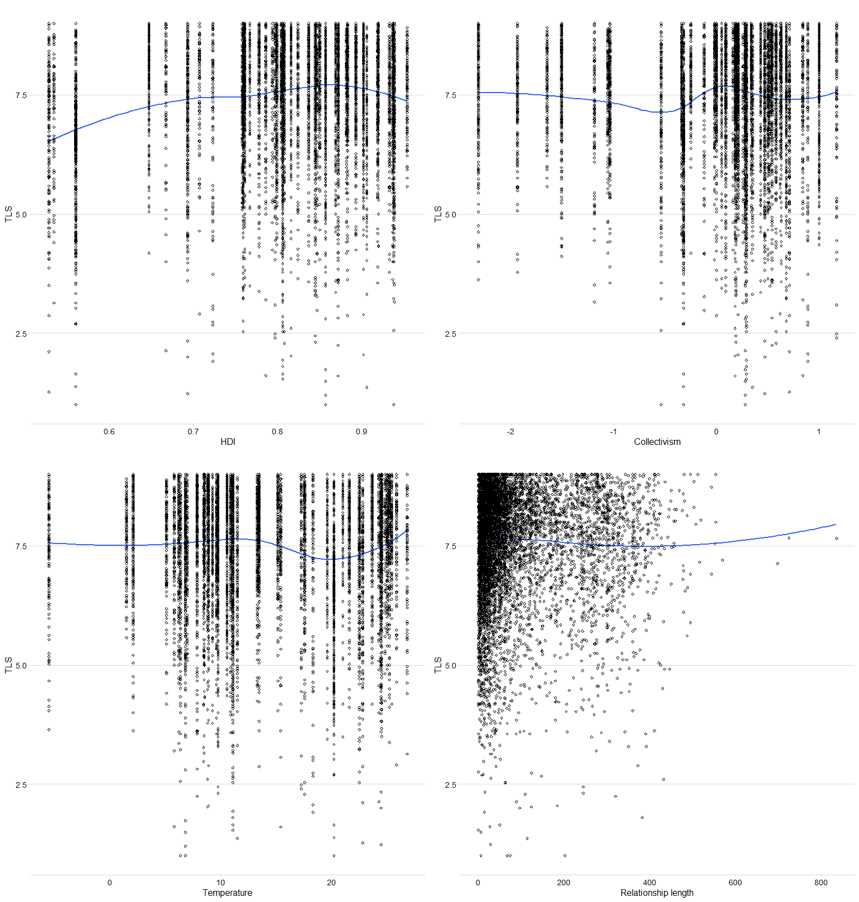

**Figure S2**

A scatterplot depicting the non-linear relationship between the mean intimacy score and the predictor variables (i.e., HDI, Collectivism, Temperature, and participants’ relationship length).

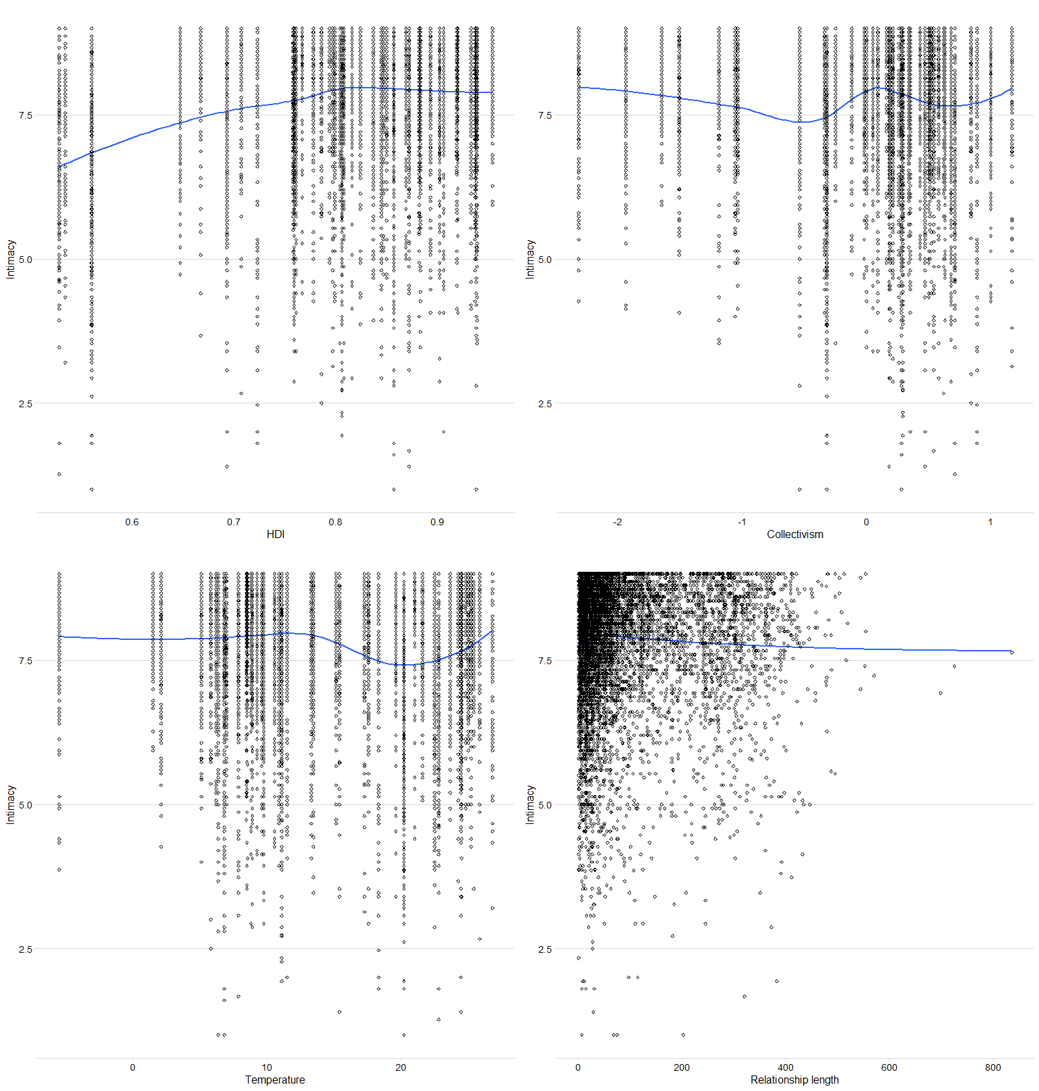

**Figure S3**

A scatterplot depicting the non-linear relationship between the mean passion score and the predictor variables (i.e., HDI, Collectivism, Temperature, and participants’ relationship length).

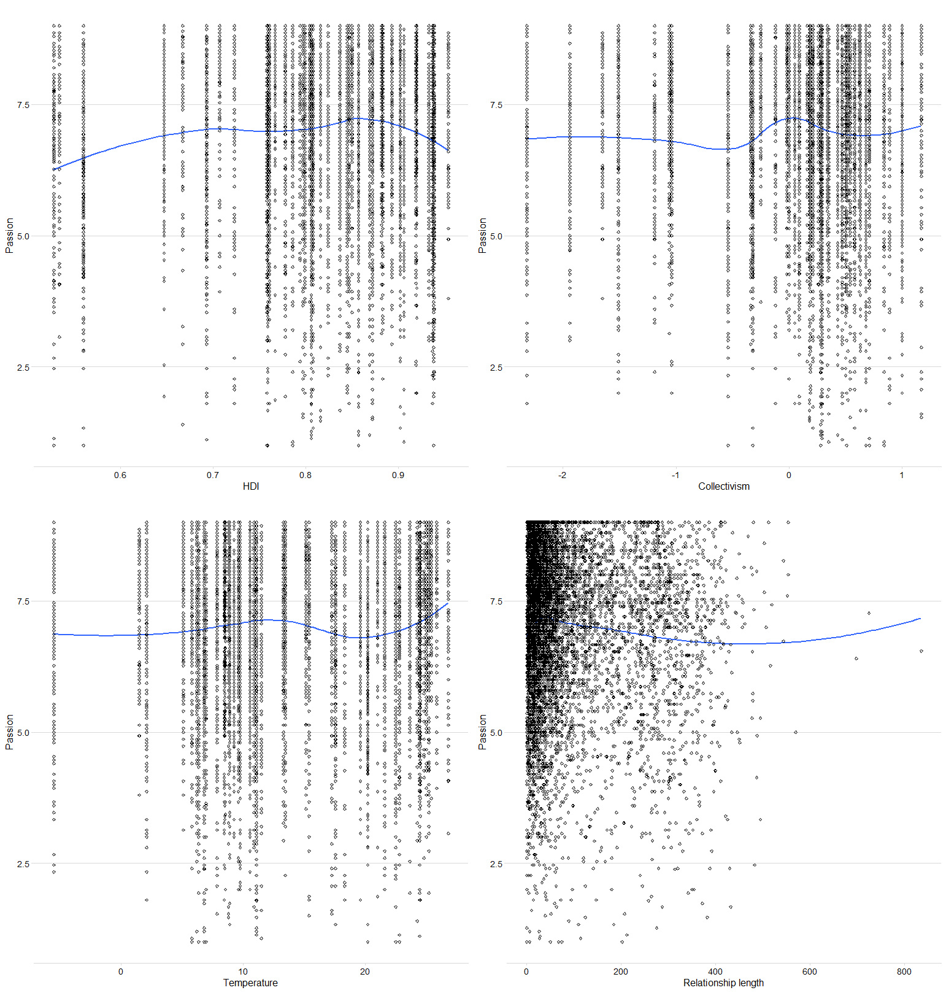

**Figure S4**

A scatterplot depicting the non-linear relationship between the mean commitment score and the predictor variables (i.e., HDI, Collectivism, Temperature, and participants’ relationship length).

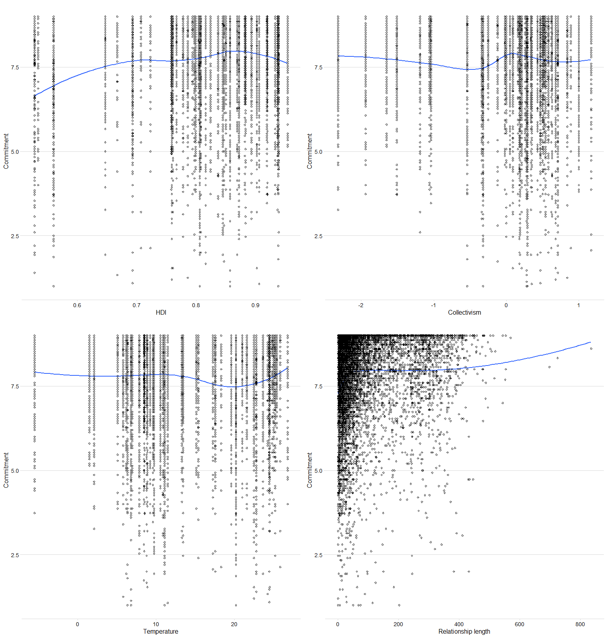

**Table S9**

Results of the multilevel linear models regressing love components (i.e., STLS-45, Intimacy, Passion, and Commitment) on countries’ levels of Human Development Index (HDI), HDI squared, Collectivism level, annual average temperature, and participants’ sex and relationship length (in months), with participants nested within countries.

|  |  |  |  |  |  |  |
| --- | --- | --- | --- | --- | --- | --- |
|  | **Fixed effects** | | | | | |
|  | **HDI** a | **HDI2** | **Collectivism** b | **Temperature** c | **Sex** d | **Relationship length** e |
| **STLS-45** |  |  |  |  |  |  |
| *β* | 1.460 | -1.286 | -0.011 | 0.071 | -0.016 | -0.010 |
| SE | 0.402 | 0.420 | 0.041 | 0.033 | 0.011 | 0.011 |
| 95% CI | [0.672,2.247] | [-2.109,-0.464] | [-0.091,0.069] | [0.007,0.136] | [-0.038,0.006] | [-0.032,0.012] |
| *p* | < 0.001*** | 0.002** | 0.788 | 0.030* | 0.147 | 0.364 |
| **Intimacy** |  |  |  |  |  |  |
| *β* | 1.738 | -1.497 | -0.005 | 0.052 | 0.027 | -0.025 |
| SE | 0.418 | 0.437 | 0.043 | 0.034 | 0.011 | 0.011 |
| 95% CI | [0.918,2.558] | [-2.355,-0.640] | [-0.089,0.079] | [-0.016,0.119] | [0.006,0.048] | [-0.046,-0.004] |
| *p* | < 0.001*** | < 0.001*** | 0.906 | 0.133 | 0.013* | 0.021* |
| **Passion** |  |  |  |  |  |  |
| *β* | 1.204 | -1.115 | -0.021 | 0.094 | -0.042 | -0.076 |
| SE | 0.467 | 0.489 | 0.048 | 0.039 | 0.011 | 0.011 |
| 95% CI | [0.287,2.120] | [-2.073,-0.156] | [-0.115,0.073] | [0.018,0.170] | [-0.064,-0.020] | [-0.098,-0.055] |
| *p* | 0.010** | 0.023* | 0.662 | 0.015* | < 0.001*** | < 0.001*** |
| **Commitment** |  |  |  |  |  |  |
| *β* | 1.024 | -0.847 | 0.003 | 0.059 | -0.022 | 0.081 |
| SE | 0.377 | 0.394 | 0.038 | 0.031 | 0.011 | 0.011 |
| 95% CI | [0.285,1.762] | [-1.618,-0.075] | [-0.071,0.078] | [-0.001,0.119] | [-0.044,0.000] | [0.059,0.103] |
| *p* | 0.007** | 0.031* | 0.933 | 0.055 | 0.054 | < 0.001*** |
| **Passionate** **Love** |  |  |  |  |  |  |
| *β* | -0.254 | 0.139 | -0.016 | 0.072 | -0.073 | -0.084 |
| SE | 0.523 | 0.548 | 0.054 | 0.044 | 0.011 | 0.011 |
| 95% CI | [-1.280,0.772] | [-0.936,1.213] | [-0.122,0.090] | [-0.013,0.157] | [-0.095,-0.051] | [-0.106,-0.063] |
| *p* | 0.627 | 0.800 | 0.765 | 0.098 | < 0.001*** | < 0.001*** |

*Note. *p < 0.05, **p < 0.01, ***p < 0.001. a Human Development Index, b Collectivism-in-group favoritism, c Average annual temperatures, d Participants’ sex with men as a reference group, e Participants’ relationship length (in months). Random effect: STLS-45 variance = 0.024, SD = 0.155, Intimacy variance = 0.027, SD = 0.164, Passion variance = 0.037, SD = 0.193, Commitment variance = 0.020, SD = 0.141, Passionate Love variance = 0.050, SD = 0.223, ICC for STLS-45 = 0.028, ICC for Intimacy = 0.033, ICC for Passion = 0.040, ICC for Commitment = 0.023, ICC for Passionate Love = 0.053, Pseudo r2 for STLS-45 = 0.035, Pseudo r2 for Intimacy =0.069, Pseudo r2 for Passion = 0.024, Pseudo r2 for Commitment = 0.036, Pseudo r2 for Passionate Love = 0.040, dfresiduals for STLS-45 = 7531, dfresiduals for Intimacy = 7531, dfresiduals for Passion = 7523, dfresiduals for Commitment = 7458, dfresiduals for Passionate Love = 7523, deviance for STLS-45= 20183.4, deviance for Intimacy = 19710.2, deviance for Passion =20688, deviance for Commitment = 20095.1, deviance for Passionate Love = 20655.3.*

**Table S10**

Results of the multilevel linear models regressing love components (i.e., STLS-45, Intimacy, Passion, and Commitment) on countries’ levels of World Modernization Index (WMI), WMI squared, Collectivism level, annual average temperature, and participants’ sex and relationship length (in months), with participants nested within countries.

|  |  |  |  |  |  |  |
| --- | --- | --- | --- | --- | --- | --- |
|  | **Fixed effects** | | | | | |
|  | **Modernization** a | **Modernization2** | **Collectivism** b | **Temperature** c | **Sex** d | **Relationship length** e |
| **STLS-45** |  |  |  |  |  |  |
| *β* | 0.884 | -0.754 | -0.017 | 0.074 | -0.019 | -0.015 |
| SE | 0.211 | 0.22 | 0.048 | 0.035 | 0.011 | 0.011 |
| 95% CI | [0.471,1.297] | [-1.186,-0.321] | [-0.111,0.076] | [0.005,0.143] | [-0.041,0.003] | [-0.037,0.007] |
| *p* | < 0.001*** | < 0.001*** | 0.715 | 0.036* | 0.095 | 0.192 |
| **Intimacy** |  |  |  |  |  |  |
| *β* | 0.999 | -0.789 | 0.007 | 0.049 | 0.021 | -0.027 |
| SE | 0.217 | 0.227 | 0.049 | 0.036 | 0.011 | 0.011 |
| 95% CI | [0.574,1.425] | [-1.234,-0.343] | [-0.089,0.104] | [-0.023,0.12] | [-0.001,0.043] | [-0.049,-0.005] |
| *p* | < 0.001*** | < 0.001*** | 0.881 | 0.181 | 0.057 | 0.015* |
| **Passion** |  |  |  |  |  |  |
| *β* | 0.768 | -0.718 | -0.043 | 0.109 | -0.045 | -0.082 |
| SE | 0.227 | 0.237 | 0.052 | 0.038 | 0.012 | 0.011 |
| 95% CI | [0.323,1.212] | [-1.183,-0.252] | [-0.144,0.058] | [0.034,0.183] | [-0.068,-0.023] | [-0.104,-0.059] |
| *p* | < 0.001*** | 0.003** | 0.404 | 0.004* | < 0.001*** | < 0.001*** |
| **Commitment** |  |  |  |  |  |  |
| *β* | 0.695 | -0.563 | -0.004 | 0.051 | -0.022 | 0.076 |
| SE | 0.198 | 0.207 | 0.045 | 0.033 | 0.012 | 0.011 |
| 95% CI | [0.306,1.084] | [-0.969,-0.156] | [-0.092,0.084] | [-0.014,0.116] | [-0.045,0] | [0.054,0.098] |
| *p* | < 0.001*** | 0.007** | 0.935 | 0.123 | 0.052 | < 0.001*** |
| **Passionate** **Love** |  |  |  |  |  |  |
| *β* | -0.044 | -0.093 | -0.057 | 0.090 | -0.073 | -0.089 |
| SE | 0.240 | 0.252 | 0.055 | 0.040 | 0.011 | 0.011 |
| 95% CI | [-0.515,0.427] | [-0.586,0.400] | [-0.165,0.050] | [0.011,0.170] | [-0.095,-0.05] | [-0.111,-0.067] |
| *p* | 0.853 | 0.712 | 0.295 | 0.026 | < 0.001*** | < 0.001*** |

*Note. *p < 0.05, **p < 0.01, ***p < 0.001. a World Modernization Index, b Collectivism-in-group favoritism, c Average annual temperatures, d Participants’ sex with men as a reference group, e Participants’ relationship length (in months). Random effect: STLS-45 variance = 0.032, SD = 0.180, Intimacy variance = 0.035, SD = 0.187, Passion variance = 0.040, SD = 0.201, Commitment variance = 0.027, SD = 0.165, Passionate Love variance = 0.047, SD = 0.216, ICC for STLS-45 = 0.037, ICC for Intimacy = 0.042, ICC for Passion = 0.043, ICC for Commitment = 0.031, ICC for Passionate Love = 0.050, Pseudo r2 for STLS-45 = 0.027, Pseudo r2 for Intimacy =0.058, Pseudo r2 for Passion = 0.023, Pseudo r2 for Commitment = 0.028, Pseudo r2 for Passionate Love = 0.046, dfresiduals for STLS-45 = 7105, dfresiduals for Intimacy = 7105, dfresiduals for Passion = 7098, dfresiduals for Commitment = 7034, dfresiduals for Passionate Love = 7098, deviance for STLS-45= 19062.2, deviance for Intimacy = 18690.1, deviance for Passion =19403.9, deviance for Commitment =18925.1, deviance for Passionate Love =19428.8.*

**Table S11**

Results of the multilevel linear models regressing love components (i.e., STLS-45, Intimacy, Passion, and Commitment) on countries’ levels of Gender Inequality Index (GII), GII squared, Collectivism level, annual average temperature, and participants’ sex and relationship length (in months), with participants nested within countries.

|  |  |  |  |  |  |  |
| --- | --- | --- | --- | --- | --- | --- |
|  | **Fixed effects** | | | | | |
|  | **GII** a | **GII2** | **Collectivism** b | **Temperature** c | **Sex** d | **Relationship length** e |
| **STLS-45** |  |  |  |  |  |  |
| *β* | 0.368 | -0.526 | -0.009 | 0.086 | -0.011 | -0.016 |
| SE | 0.140 | 0.137 | 0.035 | 0.035 | 0.011 | 0.011 |
| 95% CI | [0.094,0.642] | [-0.795,-0.258] | [-0.077,0.058] | [0.017,0.154] | [-0.034,0.011] | [-0.038,0.006] |
| *p* | 0.009** | < 0.001*** | 0.786 | 0.015* | 0.320 | 0.144 |
| **Intimacy** |  |  |  |  |  |  |
| *β* | 0.543 | -0.751 | -0.023 | 0.071 | 0.032 | -0.033 |
| SE | 0.140 | 0.137 | 0.035 | 0.035 | 0.011 | 0.011 |
| 95% CI | [0.268,0.818] | [-1.021,-0.482] | [-0.091,0.045] | [0.002,0.140] | [0.011,0.054] | [-0.054,-0.011] |
| *p* | < 0.001*** | < 0.001*** | 0.507 | 0.044* | 0.003** | 0.003** |
| **Passion** |  |  |  |  |  |  |
| *β* | 0.211 | -0.290 | 0.001 | 0.102 | -0.038 | -0.084 |
| SE | 0.162 | 0.158 | 0.040 | 0.040 | 0.011 | 0.011 |
| 95% CI | [-0.106,0.528] | [-0.600,0.020] | [-0.077,0.080] | [0.023,0.182] | [-0.061,-0.016] | [-0.106,-0.062] |
| *p* | 0.192 | 0.067 | 0.971 | 0.011* | < 0.001*** | < 0.001*** |
| **Commitment** |  |  |  |  |  |  |
| *β* | 0.283 | -0.441 | -0.011 | 0.063 | -0.017 | 0.079 |
| SE | 0.130 | 0.128 | 0.032 | 0.033 | 0.011 | 0.011 |
| 95% CI | [0.028,0.539] | [-0.691,-0.191] | [-0.074,0.052] | [-0.001,0.127] | [-0.040,0.005] | [0.057,0.101] |
| *p* | 0.030* | < 0.001*** | 0.726 | 0.055 | 0.130 | < 0.001*** |
| **Passionate** **Love** |  |  |  |  |  |  |
| *β* | -0.269 | 0.362 | 0.024 | 0.067 | -0.071 | -0.086 |
| SE | 0.168 | 0.164 | 0.041 | 0.042 | 0.011 | 0.011 |
| 95% CI | [-0.598,0.060] | [0.041,0.684] | [-0.057,0.105] | [-0.016,0.149] | [-0.094,-0.049] | [-0.108,-0.064] |
| *p* | 0.109 | 0.027* | 0.561 | 0.112 | < 0.001*** | < 0.001*** |

*Note. *p < 0.05, **p < 0.01, ***p < 0.001. a Gender Inequality Index, b Collectivism-in-group favoritism, c Temperature–Average annual temperatures, d Participants’ sex with men as a reference group, e Participants’ relationship length (in months). Random effect: STLS-45 variance = 0.030, SD = 0.172, Intimacy variance = 0.029, SD = 0.171, Passion variance = 0.044, SD = 0.210, Commitment variance = 0.025, SD = 0.158, Passionate Love variance = 0.049, SD = 0.221, ICC for STLS-45 = 0.035, ICC for Intimacy = 0.037, ICC for Passion = 0.047, ICC for Commitment = 0.029, ICC for Passionate Love = 0.052, Pseudo r2 for STLS-45 = 0.029, Pseudo r2 for Intimacy =0.062, Pseudo r2 for Passion = 0.019, Pseudo r2 for Commitment = 0.032, Pseudo r2 for Passionate Love = 0.041, dfresiduals for STLS-45 = 7186, dfresiduals for Intimacy = 7186, dfresiduals for Passion = 7178, dfresiduals for Commitment = 7113, dfresiduals for Passionate Love = 7178, deviance for STLS-45= 19107, deviance for Intimacy = 18574.3, deviance for Passion =19601.2, deviance for Commitment = 19040.2, deviance for Passionate Love = 19729.*

**Table S12**

Results of the multilevel linear models regressing love components (i.e., STLS-45, intimacy, passion, and commitment) on countries’ levels of Human Development Index (HDI), Collectivism level, annual average temperature, and participants’ sex and length of relationship (in months), with participants nested within countries (the original dataset).

|  |  |  |  |  |  |  |
| --- | --- | --- | --- | --- | --- | --- |
|  | **Fixed effects** | | | | |  |
|  | **HDI** a | **Collectivism** b | **Temperature** c | **Sex** d | **Relationship length** e | |
| **STLS-45** |  |  |  |  |  | |
| *β* | 0.237 | 0.076 | 0.097 | -0.023 | -0.013 | |
| SE | 0.043 | 0.033 | 0.035 | 0.011 | 0.011 | |
| 95% CI | [0.152,0.322] | [0.013,0.14] | [0.029,0.165] | [-0.044,-0.001] | [-0.035,0.009] | |
| *p* | < 0.001*** | 0.019* | 0.005** | 0.041* | 0.236 | |
| **Intimacy** |  |  |  |  |  | |
| *β* | 0.317 | 0.097 | 0.083 | 0.02 | -0.028 | |
| SE | 0.046 | 0.035 | 0.037 | 0.011 | 0.011 | |
| 95% CI | [0.226,0.408] | [0.028,0.165] | [0.010,0.155] | [-0.001,0.041] | [-0.049,-0.007] | |
| *p* | < 0.001*** | 0.006** | 0.026* | 0.065 | 0.009** | |
| **Passion** |  |  |  |  |  | |
| *β* | 0.145 | 0.055 | 0.117 | -0.047 | -0.079 | |
| SE | 0.049 | 0.037 | 0.039 | 0.011 | 0.011 | |
| 95% CI | [0.050,0.241] | [-0.016,0.127] | [0.041,0.193] | [-0.069,-0.025] | [-0.100,-0.057] | |
| *p* | 0.003** | 0.131 | 0.003** | < 0.001*** | < 0.001*** | |
| **Commitment** |  |  |  |  |  | |
| *β* | 0.218 | 0.061 | 0.075 | -0.028 | 0.079 | |
| SE | 0.039 | 0.030 | 0.032 | 0.011 | 0.011 | |
| 95% CI | [0.141,0.296] | [0.003,0.119] | [0.013,0.137] | [-0.050,-0.006] | [0.057,0.100] | |
| *p* | < 0.001*** | 0.039* | 0.018* | 0.012* | < 0.001*** | |
| **Passionate** **Love** |  |  |  |  |  | |
| *β* | -0.123 | -0.026 | 0.069 | -0.072 | -0.084 | |
| SE | 0.052 | 0.040 | 0.042 | 0.011 | 0.011 | |
| 95% CI | [-0.226,-0.02] | [-0.103,0.052] | [-0.013,0.151] | [-0.094,-0.05] | [-0.106,-0.063] | |
| *p* | 0.019* | 0.516 | 0.099 | < 0.001*** | < 0.001*** | |

*Note. *p < 0.05, **p < 0.01, ***p < 0.001. a Human Development Index, b Collectivism-in-group favoritism, c Average annual temperatures, d Participants’ sex with men as a reference group, e Participants’ relationship in months. Random effect: STLS-45 variance = 0.030, SD = 0.173, Intimacy variance = 0.035, SD = 0.187, Passion variance = 0.041, SD = 0.203, Commitment variance = 0.023, SD = 0.152, Passionate Love variance = 0.050, SD = 0.223, ICC for STLS-45 = 0.035, ICC for Intimacy = 0.043, ICC for Passion = 0.044, ICC for Commitment = 0.027, ICC for Passionate Love = 0.053, Pseudo r2 for STLS-45 = 0.033, Pseudo r2 for Intimacy =0.068, Pseudo r2 for Passion = 0.022, Pseudo r2 for Commitment = 0.036, Pseudo r2 for Passionate Love = 0.041, dfresiduals for STLS-45 = 7517, dfresiduals for Intimacy = 7517, dfresiduals for Passion = 7509, dfresiduals for Commitment = 7444, dfresiduals for Passionate Love = 7509, deviance for STLS-45= 20047.7, deviance for Intimacy =19542.8, deviance for Passion =20527.1, deviance for Commitment = 19932.8, deviance for Passionate Love = 20591.2.*

**Table S13**

Results of the multilevel linear models regressing love components (i.e., STLS-45, Intimacy, Passion, and Commitment) on countries’ levels of Modernization Index, Collectivism level, annual average temperature, and participants’ sex and length of relationship (in months), with participants nested within countries (the original dataset).

|  |  |  |  |  |  |  |
| --- | --- | --- | --- | --- | --- | --- |
|  | **Fixed effects** | | | | |  |
|  | **Modernization** a | **Collectivism** b | **Temperature** c | **Sex** d | **Relationship length** e | |
| **STLS-45** |  |  |  |  |  | |
| ***β*** | 0.185 | 0.083 | 0.054 | -0.026 | -0.018 | |
| SE | 0.053 | 0.043 | 0.039 | 0.011 | 0.011 | |
| 95% CI | [0.080,0.289] | [-0.001,0.168] | [-0.022,0.131] | [-0.049,-0.004] | [-0.040,0.004] | |
| *p* | < 0.001*** | 0.053 | 0.165 | 0.022* | 0.111 | |
| **Intimacy** |  |  |  |  |  | |
| ***β*** | 0.269 | 0.113 | 0.029 | 0.014 | -0.031 | |
| SE | 0.056 | 0.045 | 0.041 | 0.011 | 0.011 | |
| 95% CI | [0.160,0.378] | [0.025,0.202] | [-0.052,0.109] | [-0.008,0.036] | [-0.052,-0.009] | |
| *p* | < 0.001*** | 0.012* | 0.486 | 0.221 | 0.006** | |
| **Passion** |  |  |  |  |  | |
| ***β*** | 0.101 | 0.053 | 0.091 | -0.05 | -0.084 | |
| SE | 0.056 | 0.045 | 0.041 | 0.012 | 0.011 | |
| 95% CI | [-0.009,0.211] | [-0.036,0.142] | [0.010,0.172] | [-0.073,-0.028] | [-0.107,-0.062] | |
| *p* | 0.071 | 0.243 | 0.028* | < 0.001*** | < 0.001*** | |
| **Commitment** |  |  |  |  |  | |
| ***β*** | 0.172 | 0.072 | 0.036 | -0.030 | 0.073 | |
| SE | 0.049 | 0.039 | 0.036 | 0.012 | 0.011 | |
| 95% CI | [0.077,0.268] | [-0.005,0.149] | [-0.035,0.106] | [-0.052,-0.007] | [0.051,0.096] | |
| *p* | < 0.001*** | 0.067 | 0.322 | 0.010* | < 0.001*** | |
| **Passionate love** |  |  |  |  |  | |
| ***β*** | -0.131 | -0.046 | 0.088 | -0.072 | -0.089 | |
| SE | 0.055 | 0.044 | 0.040 | 0.012 | 0.011 | |
| 95% CI | [-0.238,-0.024] | [-0.132,0.041] | [0.01,0.167] | [-0.095,-0.05] | [-0.111,-0.067] | |
| *p* | 0.016* | 0.301 | 0.028* | < 0.001*** | < 0.001*** | |

*Note.* \**p* < 0.05, \*\**p* < 0.01, \*\*\**p* < 0.001. a Human Development Index, b Collectivism-in-group favoritism, c Average annual temperatures, d Participants’ sex with men as a reference group, e Participants’ relationship length in months. Random effect: STLS-45 variance = 0.042, SD = 0.206, Intimacy variance = 0.047, SD = 0.216, Passion variance = 0.050, SD = 0.223, Commitment variance = 0.034, SD = 0.184, Passionate love variance = 0.047, SD = 0.217, ICC for STLS-45 = 0.049, ICC for Intimacy = 0.056, ICC for Passion = 0.053, ICC for Commitment = 0.039, ICC for Passionate love = 0.050, Pseudo *r2* for STLS-45 = 0.019, Pseudo *r2* for Intimacy = 0.049, Pseudo *r2* for Passion = 0.017, Pseudo *r2* for Commitment = 0.023, Pseudo *r2* for Passionate love = 0.046, dfresiduals for STLS-45 = 7091, dfresiduals for Intimacy = 7091, dfresiduals for Passion = 7084, dfresiduals for Commitment = 7020, dfresiduals for Passionate love = 7084, deviance for STLS-45 = 18928, deviance for Intimacy = 18523.7, deviance for Passion = 19326.1, deviance for Commitment = 18782.2, deviance for Passionate love = 19382.8.

**Table S14**

Results of the multilevel linear models regressing love components (i.e., STLS-45, Intimacy, Passion, and Commitment) on countries’ levels of Gender Inequality Index, Collectivism level, annual average temperature, and participants’ sex and length of relationship (in months), with participants nested within countries (the original dataset).

|  |  |  |  |  |  |  |
| --- | --- | --- | --- | --- | --- | --- |
|  | **Fixed effects** | | | | |  |
|  | **Gender Inequality** a | **Collectivism** b | **Temperature** c | **Sex** d | **Relationship length** e | |
| **STLS-45** |  |  |  |  |  | |
| ***β*** | -0.140 | 0.038 | 0.073 | -0.018 | -0.020 | |
| SE | 0.051 | 0.038 | 0.041 | 0.011 | 0.011 | |
| 95% CI | [-0.240,-0.039] | [-0.037,0.113] | [-0.008,0.154] | [-0.04,0.004] | [-0.042,0.002] | |
| *p* | 0.006** | 0.317 | 0.078 | 0.115 | 0.079 | |
| **Intimacy** |  |  |  |  |  | |
| ***β*** | -0.181 | 0.043 | 0.054 | 0.025 | -0.036 | |
| SE | 0.058 | 0.044 | 0.047 | 0.011 | 0.011 | |
| 95% CI | [-0.295,-0.067] | [-0.042,0.128] | [-0.038,0.145] | [0.003,0.047] | [-0.058,-0.015] | |
| *p* | 0.002** | 0.322 | 0.251 | 0.023* | < 0.001*** | |
| **Passion** |  |  |  |  |  | |
| ***β*** | -0.070 | 0.028 | 0.095 | -0.043 | -0.086 | |
| SE | 0.052 | 0.039 | 0.042 | 0.011 | 0.011 | |
| 95% CI | [-0.172,0.032] | [-0.048,0.105] | [0.013,0.177] | [-0.065,-0.021] | [-0.108,-0.064] | |
| *p* | 0.179 | 0.471 | 0.024* | < 0.001*** | < 0.001*** | |
| **Commitment** |  |  |  |  |  | |
| ***β*** | -0.144 | 0.029 | 0.052 | -0.024 | 0.077 | |
| SE | 0.047 | 0.035 | 0.038 | 0.011 | 0.011 | |
| 95% CI | [-0.235,-0.052] | [-0.039,0.098] | [-0.022,0.126] | [-0.047,-0.002] | [0.054,0.099] | |
| *p* | 0.002** | 0.399 | 0.169 | 0.035* | < 0.001*** | |
| **Passionate love** |  |  |  |  |  | |
| ***β*** | 0.084 | -0.008 | 0.073 | -0.071 | -0.086 | |
| SE | 0.055 | 0.041 | 0.044 | 0.011 | 0.011 | |
| 95% CI | [-0.023,0.192] | [-0.088,0.072] | [-0.013,0.160] | [-0.093,-0.048] | [-0.108,-0.064] | |
| *p* | 0.125 | 0.844 | 0.098 | < 0.001*** | < 0.001*** | |

*Note.* \**p* < 0.05, \*\**p* < 0.01, \*\*\**p* < 0.001. a Human Development Index, b Collectivism-in-group favoritism, c Average annual temperatures, d Participants’ sex with men as a reference group, e Participants’ relationship length in months. Random effect: STLS-45 variance = 0.043, SD = 0.208, Intimacy variance = 0.056, SD = 0.237, Passion variance = 0.048, SD = 0.219, Commitment variance = 0.035, SD = 0.187, Passionate love variance = 0.055, SD = 0.235, ICC for STLS-45 = 0.051, ICC for Intimacy = 0.070, ICC for Passion = 0.052, ICC for Commitment = 0.041, ICC for Passionate love = 0.058, Pseudo *r2* for STLS-45 = 0.012, Pseudo *r2* for Intimacy = 0.024, Pseudo *r2* for Passion = 0.016, Pseudo *r2* for Commitment = 0.020, Pseudo *r2* for Passionate love = 0.033, dfresiduals for STLS-45 = 7172, dfresiduals for Intimacy = 7172, dfresiduals for Passion = 7164, dfresiduals for Commitment = 7099, dfresiduals for Passionate love = 7164, deviance for STLS-45 = 18973.2, deviance for Intimacy = 18413.9, deviance for Passion =19518.7, deviance for Commitment =18900.3, deviance for Passionate Love = 19687.6.

**Table S15**

Detailed participants’ descriptive with respect to countries.

|  |  |  |  |  |  |  |  |  |  |  |  |  |  |  |
| --- | --- | --- | --- | --- | --- | --- | --- | --- | --- | --- | --- | --- | --- | --- |
| **Country** | **ISO** | **N** | **STLS-45** | **Passionate Love** | **Intimacy** | **Passion** | **Commitment** | **Age (*SD*)** | **Men %** | **Women %** | **Dating %** | **Engaged %** | **Married %** | **Relationship length (*SD*)** |
| Algeria | DZ | 318 | 7.44 | 0.96 (0.18) | 7.43 (1.26) | 7.09 (1.59) | 7.79 (1.39) | 29.9 (7.94) | 44.30 | 55.70 | 43.40 | 13.80 | 42.80 | 5.79 (5.99) |
| Australia | AU | 250 | 7.74 | 0.88 (0.16) | 8.07 (0.80) | 7.11 (1.48) | 8.04 (1.02) | 32.0 (10.8) | 44.40 | 55.60 | 49.20 | 10.40 | 40 | 7.97 (8.80) |
| Austria | AT | 117 | 7.07 | 0.83 (0.17) | 7.59 (1.44) | 6.23 (1.67) | 7.38 (1.57) | 28.4 (11.4) | 40.40 | 59.60 | 72.90 | 7.80 | 19.30 | 5.85 (7.82) |
| Belgium | BE | 256 | 7.56 | 0.88 (0.13) | 7.88 (0.85) | 6.95 (1.30) | 7.84 (1.04) | 30.6 (9.92) | 44.50 | 55.50 | 66.40 | 6.20 | 27 | 7.10 (7.96) |
| Brazil | BR | 171 | 7.64 | 0.92 (0.12) | 7.82 (0.90) | 7.21 (1.22) | 7.9 (1.04) | 30.7 (12.7) | 47.40 | 52.60 | 59.10 | 3.50 | 36.80 | 6.60 (8.18) |
| Chile | CL | 104 | 7.49 | 0.85 (0.16) | 7.95 (0.99) | 6.79 (1.67) | 7.71 (1.39) | 33.5 (13.4) | 39.30 | 60.70 | 50.50 | 4.70 | 44.90 | 9.81 (11.0) |
| China | CN | 155 | 7.35 | 0.86 (0.22) | 7.69 (0.96) | 6.54 (1.59) | 7.54 (1.16) | 27.0 (7.90) | 43.20 | 56.80 | 60.60 | 7.10 | 31 | 2.90 (5.18) |
| Colombia | CO | 161 | 7.56 | 0.92 (0.13) | 7.86 (1.10) | 7.22 (1.34) | 7.75 (1.43) | 29.7 (8.55) | 40.20 | 59.80 | 42.10 | 28.70 | 28.70 | 5.66 (4.53) |
| Costa Rica | CR | 72 | 7.72 | 0.88 (0.14) | 8.10 (0.94) | 7.17 (1.42) | 7.95 (1.17) | 38.9 (8.77) | 50.00 | 50.00 | 25 | 11.10 | 63.90 | 9.03 (7.44) |
| Croatia | HR | 224 | 7.62 | 0.88 (0.15) | 7.96 (0.99) | 7.00 (1.43) | 7.89 (1.21) | 33.5 (12.8) | 41.10 | 58.90 | 51.80 | 1.80 | 46.40 | 10.1 (10.0) |
| Cuba | CU | 175 | 7.73 | 0.87 (0.16) | 8.21 (0.98) | 7.11 (1.58) | 7.85 (1.42) | 33.2 (13.9) | 45.10 | 54.90 | 10.90 | 48 | 41.10 | 8.87 (10.4) |
| El Salvador | SV | 72 | 7.67 | 0.90 (0.15) | 7.99 (1.10) | 7.26 (1.65) | 7.86 (1.44) | 28.5 (9.98) | 38.80 | 61.20 | 11.20 | 58.80 | 30 | 5.73 (6.58) |
| Estonia | EE | 146 | 7.62 | 0.94 (0.15) | 7.75 (0.92) | 7.22 (1.24) | 7.87 (1.16) | 28.7 (9.69) | 45.90 | 54.10 | 8.20 | 65.80 | 24.70 | 6.28 (7.62) |
| Georgia | GE | 118 | 7.38 | 0.86 (0.15) | 7.86 (1.09) | 6.80 (1.61) | 7.5 (1.42) | 28.2 (11.0) | 47.50 | 52.50 | 55.90 | 3.40 | 40.70 | 4.06 (6.17) |
| Germany | DE | 81 | 7.12 | 0.84 (0.17) | 7.69 (1.30) | 6.36 (1.43) | 7.31 (1.38) | 29.2 (7.92) | 41.10 | 58.90 | 72.60 | 5.30 | 22.10 | 5.23 (6.37) |
| Greece | GR | 136 | 7.46 | 0.92 (0.18) | 7.75 (1.16) | 7.08 (1.57) | 7.57 (1.28) | 34.9 (11.2) | 39.60 | 60.40 | 48.20 | 7.90 | 43.20 | 8.14 (8.59) |
| Hungary | HU | 827 | 7.94 | 0.92 (0.12) | 8.13 (0.88) | 7.52 (1.31) | 8.17 (1.22) | 29.6 (10.8) | 50.20 | 49.80 | 62.80 | 8.10 | 29 | 6.90 (8.98) |
| India | IN | 219 | 7.76 | 0.93 (0.12) | 7.94 (0.93) | 7.36 (1.27) | 7.99 (1.14) | 30.1 (10.7) | 47.00 | 53.00 | 46.60 | 2.70 | 50.70 | 7.60 (8.30) |
| Indonesia | ID | 89 | 7.68 | 0.98 (0.13) | 7.76 (1.09) | 7.58 (1.24) | 7.6 (1.52) | 28.5 (10.4) | 40.40 | 59.60 | 56.20 | 4.50 | 39.30 | 6.50 (5.89) |
| Iran | ID | 94 | 7.50 | 0.89 (0.15) | 7.73 (1.28) | 7.00 (1.80) | 7.75 (1.57) | 32.3 (9.83) | 40.40 | 59.60 | 33.90 | 6.40 | 59.60 | 9.39 (8.80) |
| Italy | IT | 269 | 7.79 | 0.92 (0.12) | 8.01 (0.95) | 7.34 (1.23) | 8.03 (1.13) | 33.0 (12.4) | 40.30 | 59.70 | 12.60 | 48.10 | 39.20 | 10.3 (10.3) |
| Jordan | JO | 93 | 7.05 | 1.00 (0.14) | 7.07 (1.85) | 7.04 (1.89) | 7.85 (1.37) | 30.9 (10.1) | 48.40 | 51.60 | 36.60 | 7.50 | 55.90 | 7.21 (7.53) |
| Lithuania | LT | 168 | 7.54 | 0.87 (0.17) | 7.88 (0.98) | 6.88 (1.59) | 7.86 (1.21) | 29.1 (10.2) | 48.80 | 51.20 | 59.50 | 4.20 | 36.30 | 7.81 (8.74) |
| Malaysia | MY | 150 | 7.88 | 0.97 (0.06) | 7.95 (0.75) | 7.67 (0.81) | 8.03 (0.71) | 39.5 (9.64) | 50.00 | 50.00 | 13.30 | 4.70 | 78.70 | 12.7 (8.55) |
| Mexico | MX | 89 | 7.78 | 0.94 (0.14) | 8.02 (0.94) | 7.51 (1.35) | 7.78 (1.24) | 26.5 (8.73) | 46.10 | 53.90 | 0 | 77.50 | 22.50 | 4.16 (5.06) |
| Nigeria | NG | 82 | 7.21 | 0.97 (0.13) | 7.25 (1.31) | 6.99 (1.48) | 7.42 (1.43) | 29.0 (7.31) | 40.00 | 60.00 | 44.70 | 15.30 | 38.80 | 4.45 (4.59) |
| Norway | NO | 112 | 7.66 | 0.88 (0.10) | 8.10 (0.68) | 7.15 (1.06) | 7.72 (0.98) | 23.4 (3.20) | 44.60 | 55.40 | 64.30 | 0.90 | 34.80 | 2.90 (1.99) |
| Pakistan | PK | 467 | 6.49 | 0.95 (0.17) | 6.56 (1.37) | 6.19 (1.39) | 6.72 (1.56) | 28.1 (8.91) | 47.50 | 52.50 | 45 | 20.30 | 34.70 | 5.13 (6.81) |
| Peru | PE | 111 | 7.40 | 0.89 (0.13) | 7.73 (1.02) | 6.91 (1.4) | 7.59 (1.23) | 24.6 (8.73) | 40.00 | 60.00 | 71.50 | 13.10 | 14.60 | 3.57 (5.47) |
| Poland | PL | 364 | 7.74 | 0.93 (0.12) | 7.92 (1.11) | 7.33 (1.36) | 7.97 (1.29) | 28.9 (9.30) | 53.00 | 47.00 | 42.90 | 17.90 | 37.60 | 7.26 (7.77) |
| Portugal | PT | 157 | 7.88 | 0.93 (0.11) | 8.10 (0.86) | 7.59 (1.22) | 8.01 (1.07) | 29.4 (9.56) | 39.80 | 60.20 | 65.20 | 3.10 | 31.10 | 6.11 (6.57) |
| Romania | RE | 151 | 7.73 | 0.90 (0.14) | 8.06 (1.07) | 7.29 (1.56) | 7.84 (1.62) | 30.1 (11.1) | 50.30 | 49.70 | 1.30 | 60.90 | 37.70 | 8.06 (9.42) |
| Russia | RE | 150 | 7.59 | 0.87 (0.15) | 7.90 (1.08) | 6.89 (1.59) | 7.97 (1.21) | 29.9 (10.1) | 45.30 | 54.70 | 37.30 | 6 | 56 | 7.75 (7.50) |
| Serbia | RS | 295 | 7.61 | 0.87 (0.15) | 8.09 (0.92) | 7.04 (1.48) | 7.7 (1.28) | 27.3 (10.1) | 42.70 | 57.30 | 76.30 | 2.40 | 21.40 | 5.46 (7.50) |
| Slovakia | SK | 282 | 7.36 | 0.89 (0.17) | 7.62 (1.38) | 6.73 (1.65) | 7.7 (1.53) | 30.1 (13.1) | 40.10 | 59.90 | 63.10 | 8.50 | 28.10 | 7.88 (11.2) |
| Slovenia | SI | 449 | 7.79 | 0.88 (0.14) | 8.10 (0.93) | 7.14 (1.35) | 8.12 (1.04) | 32.1 (11.6) | 49.70 | 50.30 | 61.50 | 2.70 | 35.40 | 9.94 (9.86) |
| South Korea | SS | 130 | 6.91 | 0.87 (0.16) | 7.30 (1.25) | 6.36 (1.56) | 7.06 (1.34) | 35.7 (11.7) | 50.80 | 49.20 | 37.70 | 0.80 | 61.50 | 10.6 (10.4) |
| Spain | ES | 260 | 7.69 | 0.90 (0.12) | 7.94 (0.94) | 7.18 (1.27) | 7.94 (1.1) | 33.7 (13.1) | 39.80 | 60.20 | 60.20 | 2.60 | 35.70 | 9.27 (10.3) |
| Sweden | SE | 194 | 7.46 | 0.84 (0.15) | 7.89 (0.98) | 6.70 (1.54) | 7.78 (1.2) | 33.2 (10.7) | 51.00 | 49.00 | 17 | 6.20 | 31.40 | 7.31 (6.86) |
| Netherlands | NP | 153 | 7.39 | 0.88 (0.13) | 7.72 (0.90) | 6.80 (1.26) | 7.64 (1.04) | 34.2 (14.9) | 43.10 | 56.90 | 60.10 | 3.30 | 36.60 | 10.5 (12.7) |
| Turkey | TR | 562 | 7.29 | 0.86 (0.18) | 7.74 (1.29) | 6.69 (1.72) | 7.43 (1.67) | 31.9 (11.7) | 42.70 | 57.30 | 49.60 | 4.30 | 45.90 | 9.79 (9.91) |
| Uganda | UG | 137 | 6.68 | 0.96 (0.21) | 6.75 (1.45) | 6.44 (1.65) | 6.83 (1.81) | 28.8 (7.80) | 59.90 | 40.10 | 39.40 | 22.50 | 36.60 | 5.13 (4.01) |
| USA | UY | 93 | 7.88 | 0.91 (0.14) | 8.19 (0.85) | 7.43 (1.42) | 8 (1.19) | 21.7 (6.66) | 40.40 | 59.60 | 86.20 | 5.30 | 8.50 | 2.62 (3.28) |
| Uruguay | UY | 217 | 7.48 | 0.83 (0.15) | 8.03 (0.96) | 6.67 (1.49) | 7.75 (1.26) | 30.0 (10.4) | 40.20 | 59.80 | 74.10 | 4.50 | 21 | 7.12 (9.30) |
| Vietnam | VN | 311 | 7.23 | 0.92 (0.13) | 7.33 (1.32) | 6.75 (1.54) | 7.58 (1.46) | 30.0 (5.78) | 40.00 | 60.00 | 28.10 | 1.60 | 70 | 5.66 (4.50) |
| All |  | 9474 | 7.51 (1.22) | 0.90 (0.15) | 7.78 (1.15) | 7.01 (1.49) | 7.75 (1.35) | 30.53 (10.95) | 45.07 | 54.74 | 49.27 | 12.72 | 38.02 | 7.30 (8.64) |